**Day 3 Assignment**

**Blockchain Essentials**

**Answer 1:**

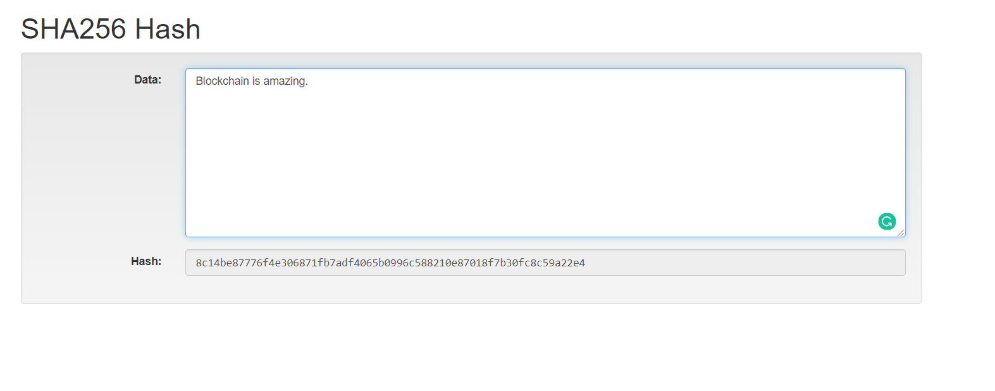

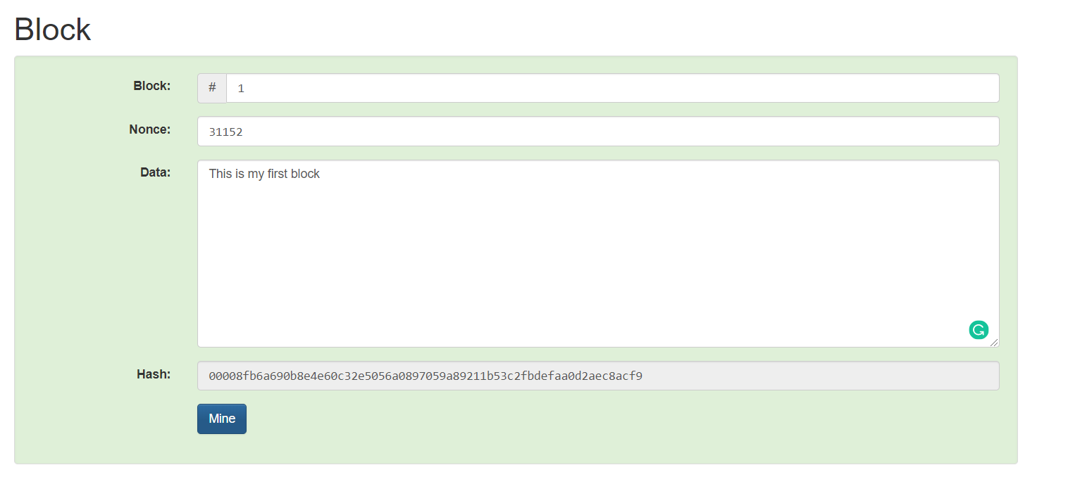

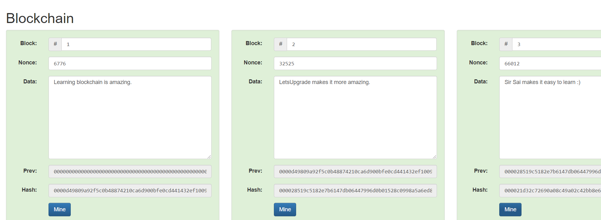

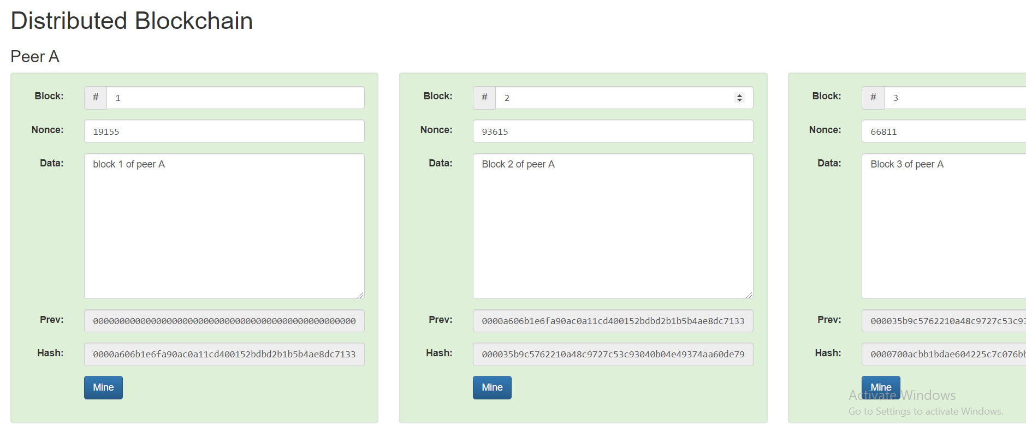

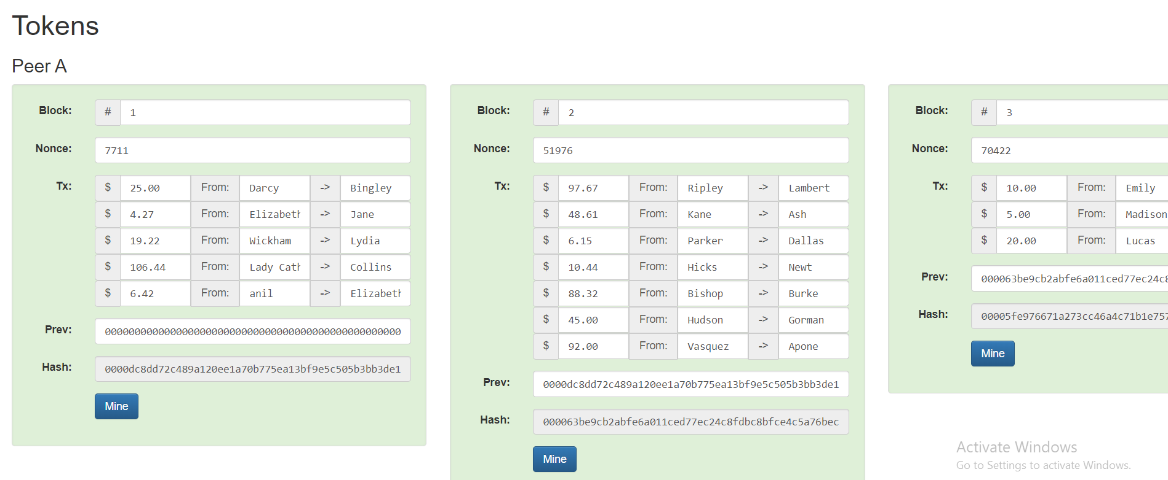

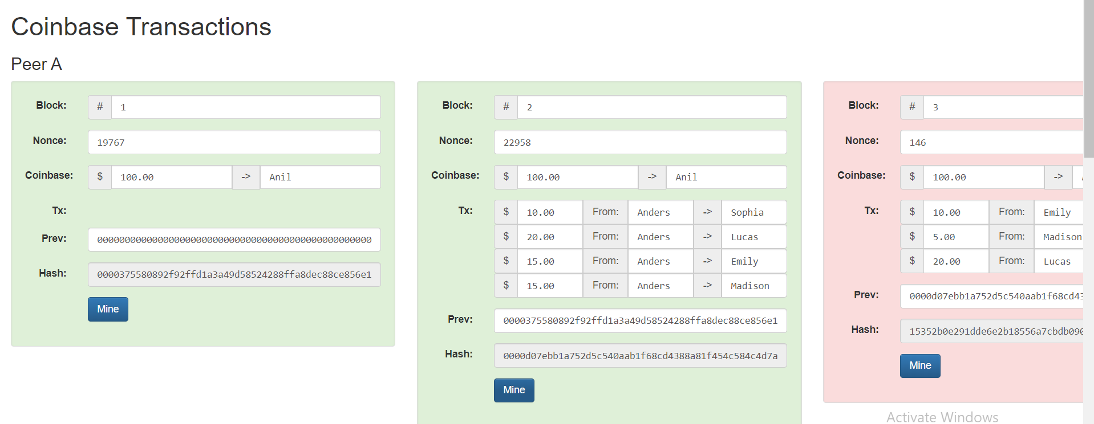

**Answer 2:**

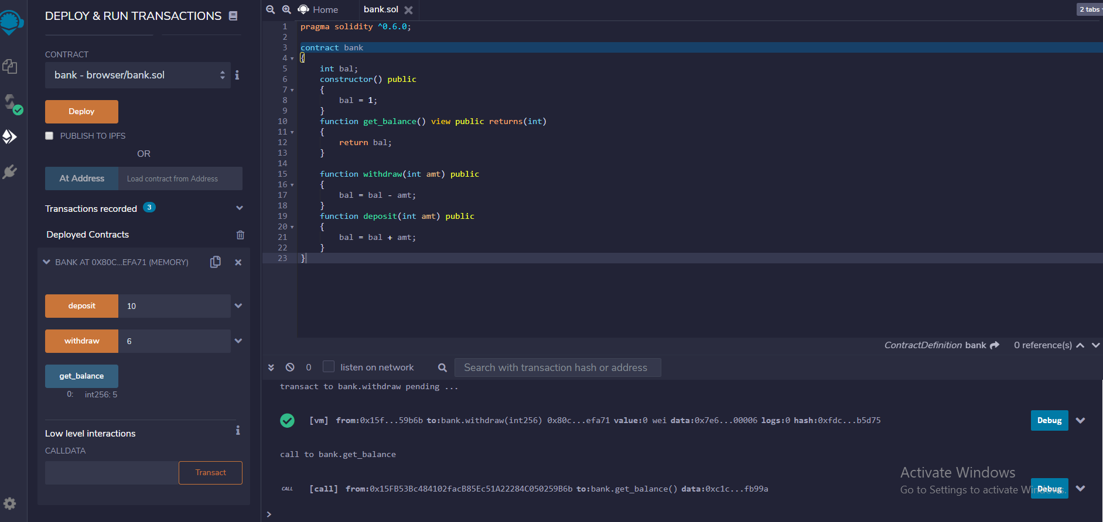

**Smart contact code:**

pragma solidity ^0.6.0;

contract bank

{

int bal;

constructor() public

{

bal = 1;

}

function get_balance() view public returns(int)

{

return bal;

}

function withdraw(int amt) public

{

bal = bal - amt;

}

function deposit(int amt) public

{

bal = bal + amt;

}

}